- Title: Project name, team members, date, partner name/logo (if permitted)
GreenStep Sustainability Challenge – Administrator side
Tuesday March 3, 2026
Minnesota GreenStep Cities - Krsitin: https://greenstep.pca.state.mn.us/
- Problem Statement & Motivation: 3-4 sentences on the problem, why it matters now, and who’s affected
It is important to reserve the resources we get from the Earth. We are living on Earth, it is our nursery. But people are exploiting the Earth too much. Therefore, it is the time now that we should learn and practice sustainable activities. For us to live well on Earth in another billion years.
The administration people are having a hard time because they have to manually enter the data. The other users are not having fun because it is just some excel sheet. Therefore, getting people to stick around is hard.
- Goals, Objectives, and Target Users: One-sentence main goal; 3-4 measurable objectives; primary users/stakeholders
An app with both desktop and mobile version for people to get engaged and have fun while learning more about sustainability.
Should have data storage, data analysis and data report with filter.
Should have user friendly and attractive interface for admin users.
Administrator will have special roles and responsibilities.
- Solution Overview: High-level approach; simple diagram (system, user flow, or architecture-lite)
Front-end: Figma to create some UI for demo first
- UI 1: Log in – ask for username and password
- UI 2: Dashboard – this is different for different user role
- For Admin, you will see all tables (actions, category, event, user role, user, report). The tables will appear as tabs/buttons.
- For regular users, you will see just events and your user profile.
- UI 3: Different view for different tables. When you click on the table buttons, it will lead to the tables.
- Action, Category, Event, User, Report: view and create and edit and delete actions
- User role: view only
- User: assign different roles to other users
- Report: filter for different purposes, download the report
- UI 4: How to work with those tables.
Back-end: system, flow, architecture
- Event (EventID, EventName, EventType, EventOwner, EventMember, StartTime, EndTime, StartDate, EndDate)
- Category (CategoryID, CategoryName, CategoryDescription, CategoryActions)
- Action (ActionID, ActionName, ActionDescription)
- User (UserID, FirstName, LastName, EmailAddress, UserName, Password, UserRole, DateJoined, Status)
- UserRoles (RoleID, RoleType)
- Report (ReportID,EventID)
- Log-in_Activities (ID, Date, Time, ActionID, UserID)
- 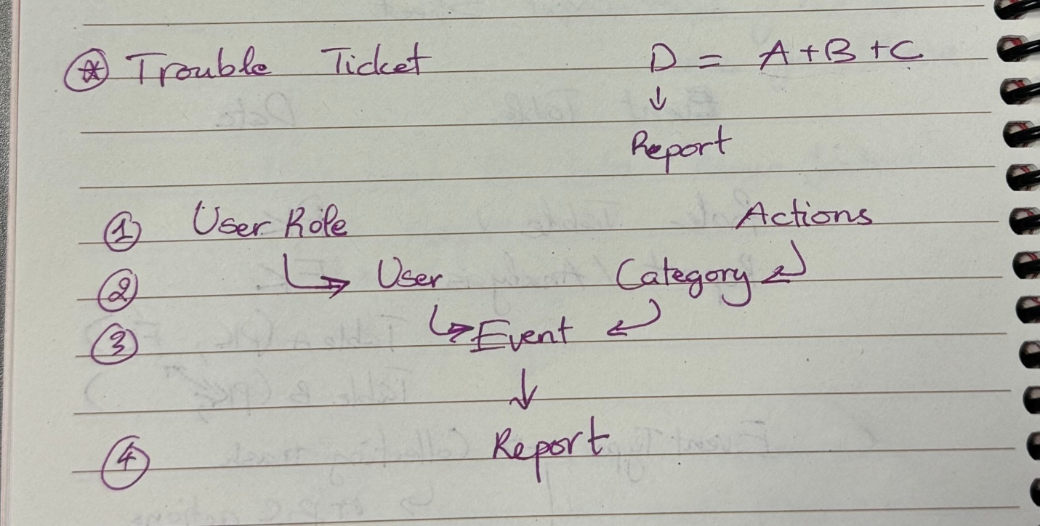
- Technical Approach: Technologies, frameworks, data sources, key integrations, known constraints
MySQL for database
Python for UI
Data sources: that link in the team channel
Constraints:
Database and UI should be able to connect. Should be able to connect to team 1 as well because we are working on the same project.
Demo in 2 weeks.
Admin sees all, regular user sees few.

- Scope & Feasibility: In-scope vs. out-of-scope; assumptions; top 2-3 risks with mitigations
In-scope: complete frame of the app with simple features; demo UI at least;
Out-of-scope: complete app with advanced features; actual UI complete;
Prevent improper contents
Too ambitious to finish in time
- Timeline & Milestones: Major milestones with dates; acceptance criteria for end-of-term deliverable
March 3: Project Proposal – first understanding of the project
March 4: Meeting with Kristin to show the proposal, get feedback
March 10: Demo 1 – the fixed proposal turns into demo1
March 11: Meeting with Kristin to show the Demo1 and get feedback. Then fixe the proposal
March 15: Final Project Description – show the final proposal after feedbacks
March 16: show Kristin the final proposal and working on the Demo2
March 24: Presentation and Demo 2
March 25: Show Kristin the Demo 2 and Data Model and Design
March 26: Data Model and Design
April 9: Testing the app
April 15: Show Kristine the Demo 3
April 16: Demo 3
April 22: (if possible) Show Kristine the Demo 4
April 28: Demo 4
April 29: Show Kristine the Demo 4
May 13: Show Kristine the final product
May 12 and 14: Final Presentation
- Collaboration & Communication: How would you communicate as a team?
Online: Teams, Zoom, Instagram, Phone messages
In-person: meet at class
- Next Steps: Top 3 actions, owners, due dates.
Actions:
- Meet with Kritine, get feedbacks from her
- Fix the proposal
- Build Demo 1
Actual code and demo done.
UI: Look good but not yet used
Database: No error in flow, constraints are satisfied, contain all data need to be used

